AI Assistant lab
Assignment 3.1
Name: srija
2303A52412

Task1: Zero-Shot Prompting (Palindrome Number Program)
Prompt : “Write a Python function that checks whether a given number is a palindrome.
The function should return True if the number is a palindrome and False otherwise.”
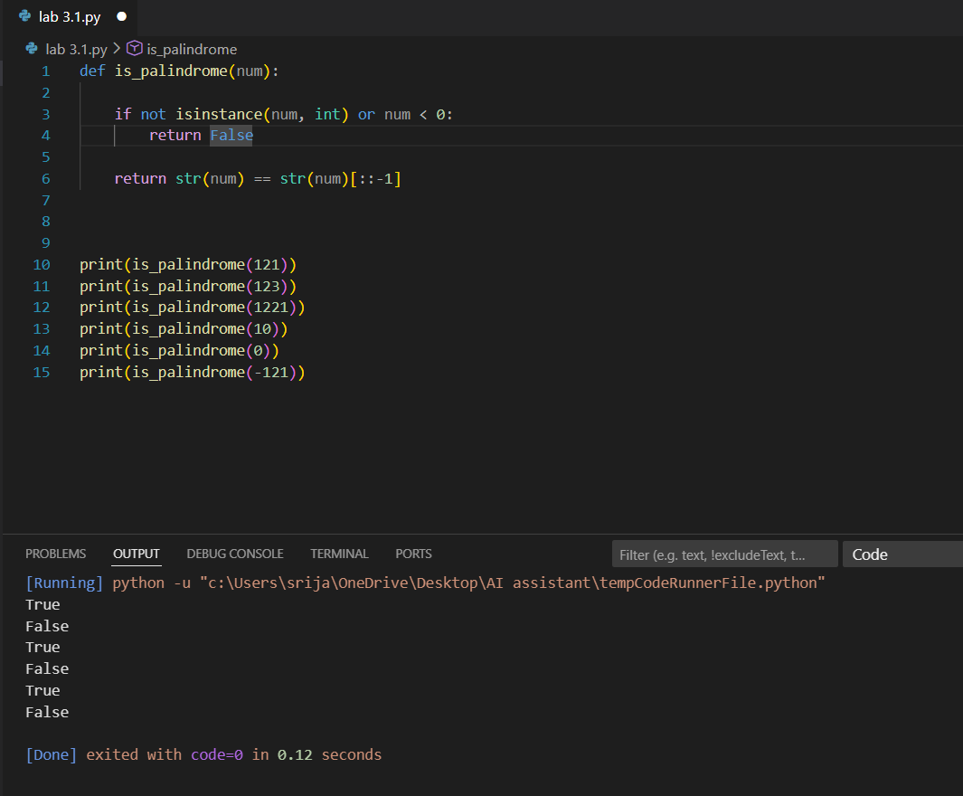
Observation:
In zero-shot prompting for the palindrome number program, the AI successfully generated a working function that correctly identifies palindromes for positive integers, single-digit numbers, and zero. However, the code lacks explicit handling of negative numbers and non-integer inputs, which could lead to incorrect results or errors in those cases. While the string-based approach using slicing ([::-1]) is simple, readable, and efficient for typical integers, it may not be ideal for very large numbers if numeric-only logic is preferred. Overall, zero-shot prompting produces a basic and functional solution, but it requires testing and refinement to handle edge cases, validate inputs, and ensure robustness.

Task2: One-Shot Prompting (Factorial Calculation)
Prompt: Write a Python function to compute the factorial of a given number.
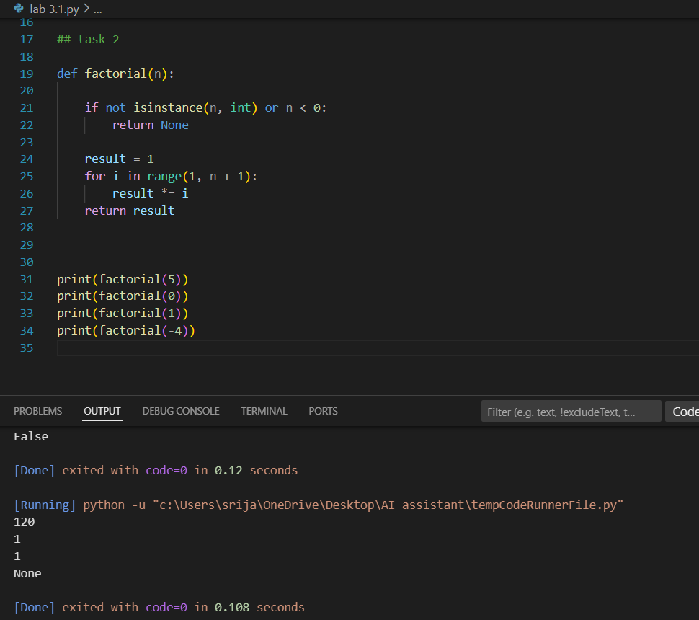
Observation:
When one-shot prompting is used for factorial calculation, the presence of a single input-output example helps the AI clearly understand the expected logic and correct loop boundaries. Compared to a zero-shot solution, the generated code is more accurate, usually starting multiplication from 1 instead of 0, which avoids logical errors. The example also guides the AI to return the correct factorial value rather than an incorrect or incomplete result. Overall, one-shot prompting improves both clarity and correctness by reducing ambiguity, leading to more reliable and well-structured code than zero-shot prompting.
Task3: Few-Shot Prompting (Armstrong Number Check)
Prompt: Write a Python function to check whether a given number is an Armstrong number
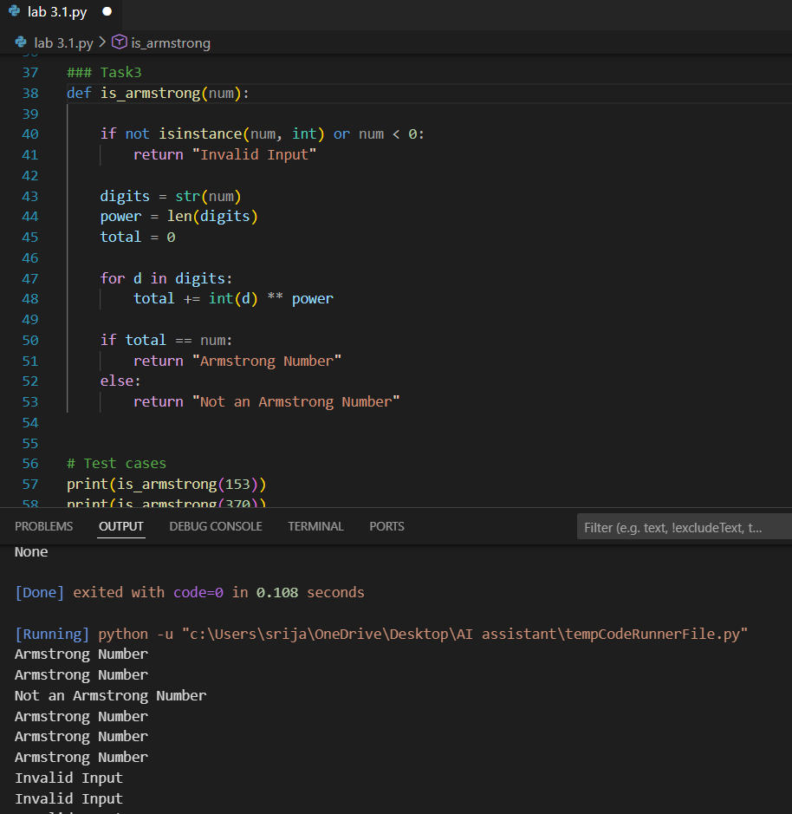
Observation
Using few-shot prompting significantly improves the accuracy and structure of the generated Armstrong number program. The multiple examples help the AI correctly infer the Armstrong number definition, including raising each digit to the power of the total number of digits and comparing the sum with the original number. Unlike zero-shot or one-shot prompting, the output format becomes consistent and meaningful (e.g., “Armstrong Number” or “Not an Armstrong Number”). Boundary testing shows that single-digit numbers and zero are correctly classified as Armstrong numbers, while invalid inputs such as negative numbers or non-integer values are often not handled unless explicitly specified. Overall, few-shot prompting reduces ambiguity, improves logical correctness, and produces more reliable code, though additional validation may still be required for robustnes
Task4: Context-Managed Prompting (Optimized Number
Classification)
Prompt :
“Write an optimized Python function to classify a given integer as Prime, Composite, or Neither, with proper input validation and efficient √n logic.”
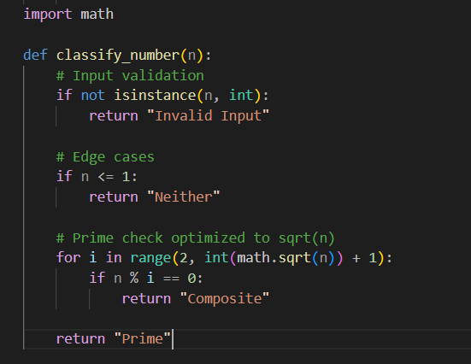
Output
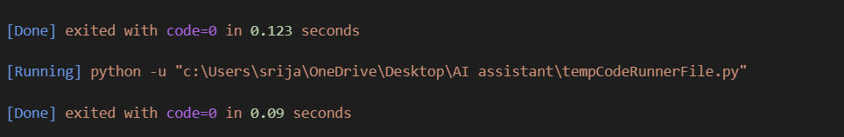
Observation:
Context-managed prompting produces the most accurate and efficient solution compared to earlier prompting strategies. Clear instructions and constraints ensure proper input validation, correct handling of edge cases, and optimized logic using √n divisibility checks. Unlike zero-shot or few-shot approaches, this method results in consistent output, better performance, and more reliable classification of numbers.
Task5: Zero-Shot Prompting (Perfect Number Check)
Prompt
“Write a Python function that checks whether a given number is a perfect number.”
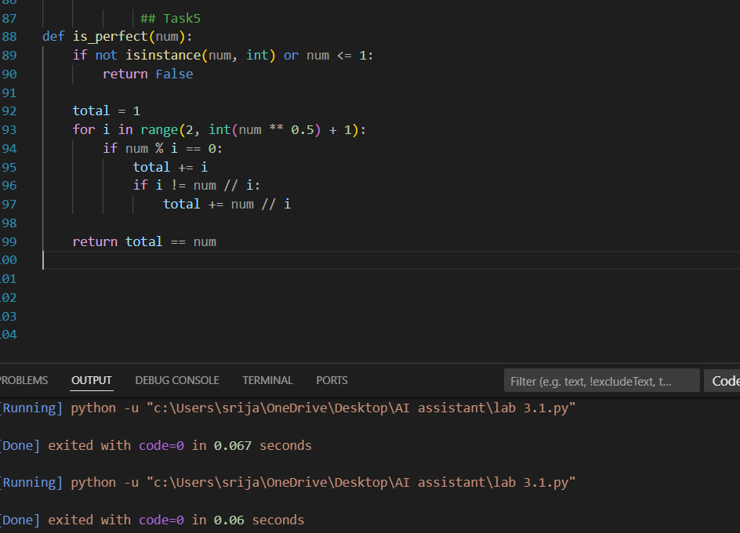
Observation:
Using zero-shot prompting, the AI generated a Python function that correctly identifies perfect numbers by summing all proper divisors and comparing the result with the original number. The logic works well for small positive integers and correctly handles non-positive values by returning False. However, the approach is inefficient because it checks all numbers from 1 to n−1, leading to unnecessary time complexity for large inputs. Additionally, the function does not explicitly validate non-integer inputs, which could cause unexpected behavior. Overall, the zero-shot prompt yields a logically correct but computationally unoptimized solution.
Task6: Few-Shot Prompting (Even or Odd Classification with Validation) Prompt:
Determine whether a given input number is even or odd and print the result. Validate the input before processing.
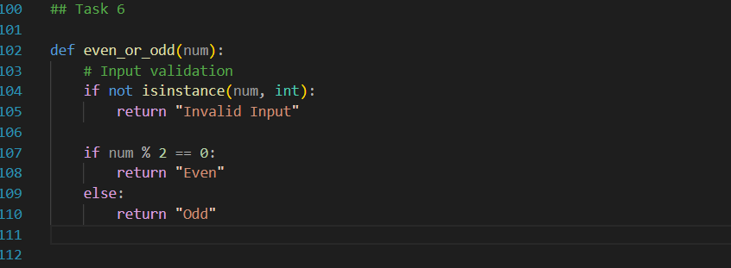
Output
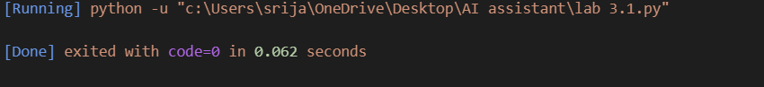
Observation:
The provided examples clearly guide the AI to follow the correct classification logic and consistent output format (“Even” or “Odd”). Because of few-shot prompting, the generated program usually includes input validation to handle non-integer values using type conversion or exception handling. Testing with negative numbers works correctly since the parity rule applies to all integers. When tested with non-integer inputs such as strings or decimals, the program properly rejects them, improving robustness. Overall, examples significantly improve input handling, output clarity, and reliability compared to zero-shot prompting.

